**Analysis about Opening a Supplements Shop in Manhattan**

**1. Introduction**

**1.1 Background**

Manhattan, often referred to by residents of the New York City area as *the City*, is the most densely populated of the five [boroughs](https://en.wikipedia.org/wiki/Boroughs_of_New_York_City) of [New York City](https://en.wikipedia.org/wiki/New_York_City), and coextensive with the County of New York, one of the [original counties](https://en.wikipedia.org/wiki/List_of_counties_in_New_York) of the [U.S. state](https://en.wikipedia.org/wiki/U.S._state) of [New York](https://en.wikipedia.org/wiki/New_York_(state)). Manhattan serves as the city's economic and administrative center, [cultural](https://en.wikipedia.org/wiki/High_culture) identifier, and historical birthplace.

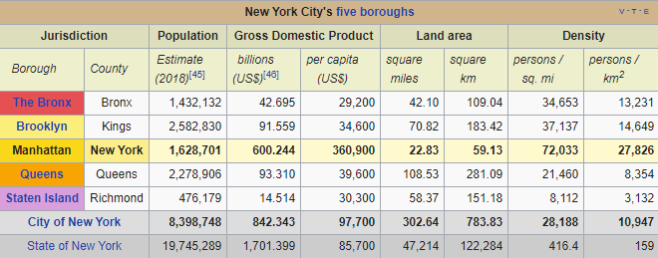

Being such a populated, dense and multicultural borough, Manhattan has a lot of social facilities to maintain a good level of prosperity. Between all of those sports facilities such as gyms are very popular since physical well-being has important impact on prosperity of the people live in Manhattan.

Having the highest per capita income in New York makes Manhattan very attractive to starting businesses.

**1.2 Interest**

A fitness supplements shop is very profitable for several reasons. One of the reason is online shopping is not trusted since there are too many fake products and getting fake product is pretty possible. Providing possible consumers to access their supplements on-hand experience is beneficial for customers. Secondly, Manhattan is very easy to commute with all transportation facilities. So, people do not have to wait for arrival of the product which may not be original.

**2. Data Acquisition and Cleaning**

**2.1 Data Sources**

Fundamental information about Manhattan is derived from Wikipedia page of Manhattan (<https://en.wikipedia.org/wiki/Manhattan>). Geographic dataset is derived from NYU Spatial Data Repository (<https://geo.nyu.edu/catalog/nyu_2451_34572>). Average rent information which is last updated January 2020 is gathered from rentcafe.com (https://www.rentcafe.com/average-rent-market-trends/us/ny/manhattan)

**2.2 Data Cleaning and Preparing**

Downloaded data was a .json file and contained coordinates of all boroughs and neighborhoods of New York. Firstly, I separated names of boroughs, neighborhoods and their latitude and longitude information. After getting related data, I created a data frame in order to make further observations. Secondly, I needed to narrow down this table of information to Manhattan related details. Creating a new data frame which contains information only about Manhattan made me able to continue to analysis. Thirdly, with the Foursquare API, I obtained all 100 avenues nearby with the radius 500 meter for each neighborhood of Manhattan. After creating another data frame which has every venues name and category, I merged all of the data frames into one in order to observe accurately.

There were several kinds of venues related to our interest. Careful inspection showed me that there were gyms, fitness centers, boxing gyms, climbing gyms, cycle studios and supplement shops. As a separate data frame, I found the number of each those facilities for each neighborhood. Moreover, I found out the total number of those facilities which is a very helpful piece of information about each region. I will introduce the findings in the next part of the report.

**3. Methodology**

**3.1 Exploring Nearby Venues**

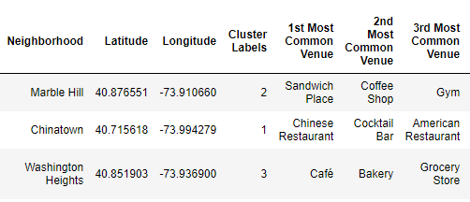I found out that there are 320 unique venue categories. Moreover, I observed that some of the neighborhoods have less than 100 venues. In order to observe which neighborhood has which kind of venues I grouped venues by their categories. After I created another data frame in order to find out the most common venues for each neighborhood. New data frames have the categories of the first ten most common venues for each neighborhood.

**3.2 Clustering and Visualizing**

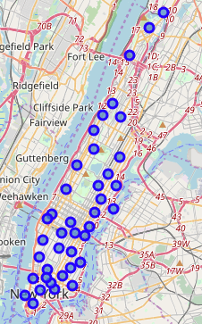I used python **folium** library to visualize geographic details of Manhattan and its boroughs and I created a map of Manhattan with boroughs superimposed on top. I used latitude and longitude values to get the visual as shown.

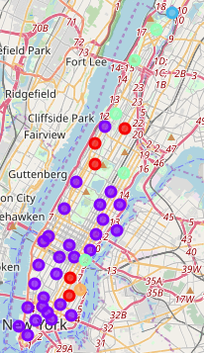

In order to make quality observations and save time, I clustered the neighborhoods into 5 clusters. While clustering I used k-means cluster with k constant is 5. I used python **folium** library to visualize geographic details of clustered Manhattan view and labeled with clusters using different colors to emphasize clusters.

There were several kinds of venues related to our interest. Careful inspection showed me that there were gyms, fitness centers, boxing gyms, climbing gyms, cycle studios and supplement shops. As a separate data frame, I found the number of each those facilities for each neighborhood. Moreover, I found out the total number of those facilities which is a very helpful piece of information about each region.

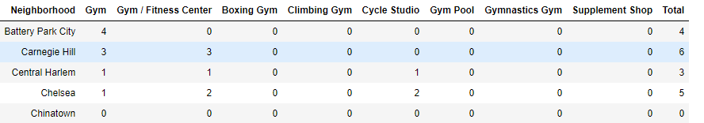

After that I obtained a descending order table in order to have a clear view about our first candidate neighborhoods.

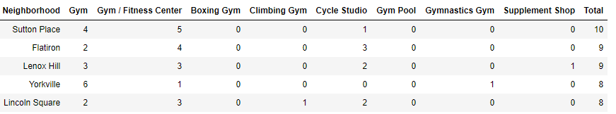

**\***These tables only shows first 5 entries

Since my data is not continuous, horizontal bar chart became very beneficial to make clear observations.

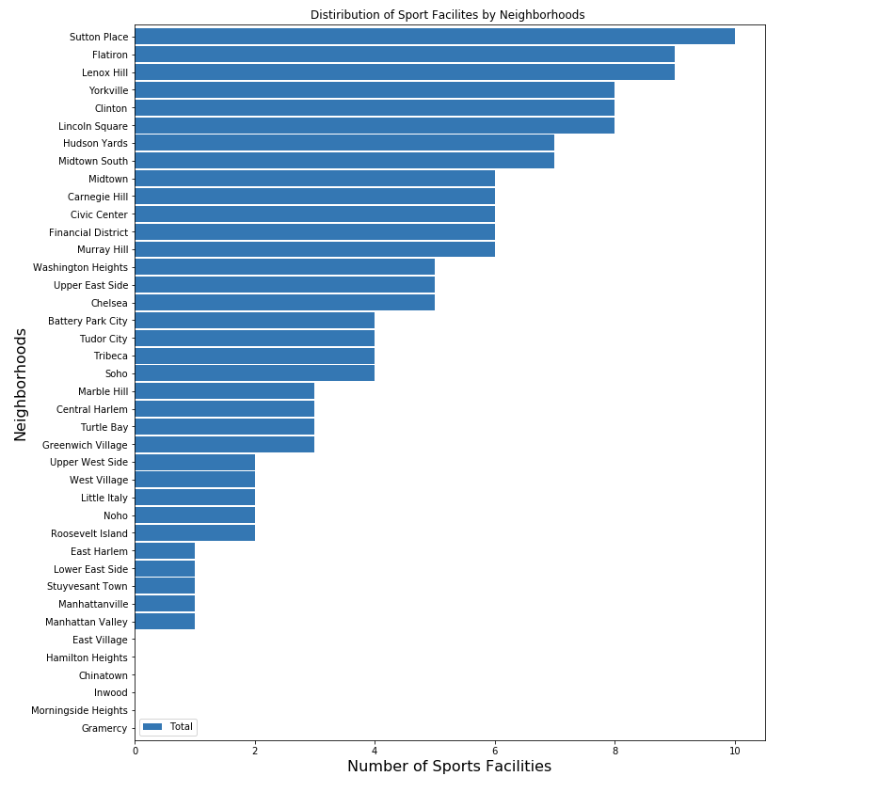

**3.2 Preparing rental data**

Firstly, I formed a data frame for each neighborhood with their corresponding average rents shown as below:

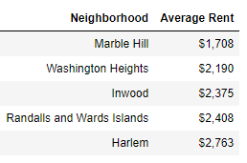

Then I specified this list of information to my top 5 candidates.

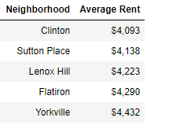

After making some adjustment in above data frame, I created another visual for rents to see the difference clearly.

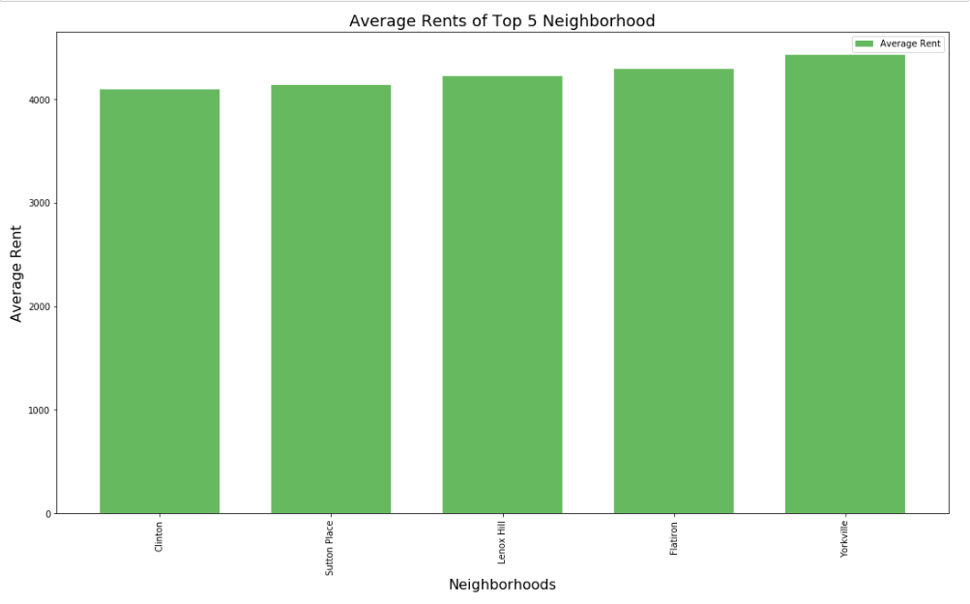

**4. Discussion and Observations**

There were several kinds of venues related to our interest. Careful inspection showed me that there were gyms, fitness centers, boxing gyms, climbing gyms, cycle studios and supplement shops.

In order to make precise suggestions I did more detailed research about top 5 candidates which are namely: Sutton Place, Flatiron, Lenox Hill, Yorkville and Clinton.

I considered them individually.

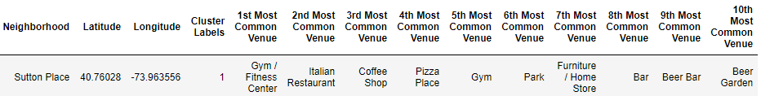

First candidate is Sutton Place since it has the most number of sport facilities. Moreover, with the above data piece I observed that first and fifth most common venues are related to my interest.

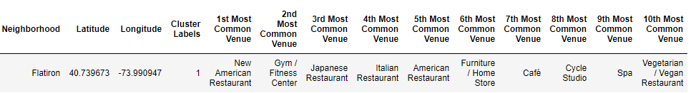

Secondly, in the Flatiron neighborhood I observed that second most common value is in the type of gym / fitness center. In addition, having the second most number of sports facilities makes Flatiron a real good candidate place.

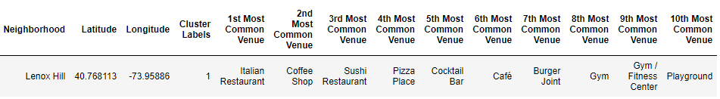

Even though Lenox Hill has the third most number of sports facilities, when I considered the most common and values gym type, it is at the ninth spot. Since Flatiron has the same amount sport facilities, Flatiron looks like a better choice comparing to Lenox Hill.

Last comparison is between Yorkville and Clinton, since they have exactly same number of sports facilities.

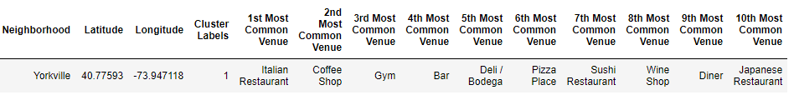

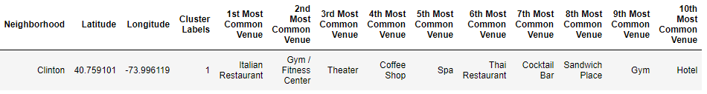

Although their statistics look similar, when I observed I noticed a small difference in the most common venues. Clinton has two sports related common value while Yorkville has only one in the top ten common venues. So Clinton becomes a better option to locate a supplement shop.

However I also observed that some of neighborhoods such as Lenox Hill, Marble Hill and Washington Heights already have supplement shops.

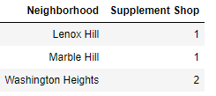

Lenox Hill has already a supplement shop so while making a choice Lenox Hill may not be a good choice.

**5. Conclusion**

After careful inspection, the most logical locations to launch supplement shop in Manhattan are:

1. **Sutton Place**

Sutton Place has the highest number of sports facilities with no other supplement shop around. Moreover, its most common venues highly rely on sports facilities. Also, its rental situation is suitable since it is the second cheapest neighborhood amoung them. All in all, all these statics makes Sutton Place as the best option to open a supplement shop.

1. **Flatiron**

Like Sutton Palace, Flatiron also do not have any supplement shops in the region. Moreover, it has the second highest number of sport facilities. Also, sports facilities take up space in the most common venues. Finally, Flatiron is the second best option right after Sutton Place.

1. **Clinton**

Clinton has the cheapest rent among others. That makes it a desirable option. However, Yorkville and Clinton have exactly same number of sports facilities. Although their statistics look similar, when I observed I noticed a small difference in the most common venues. Clinton has two sports related common value while Yorkville has only one in the top ten common venues. So Clinton becomes a better option to locate a supplement shop.

1. **Yorkville**

Yorkville has the most expensive rents. However, it is a better choice when compared to Lenox Hill. Because there is no other supplement shop in this neighborhood, unlike Lenox Hill.

1. **Lenox Hill**

Since there has already been a supplement shop and rent average is nothing special Lenox Hill is not a favorite location among the others.

**6. References**

* <https://en.wikipedia.org/wiki/Manhattan>
* <https://geo.nyu.edu/catalog/nyu_2451_34572>
* https://www.rentcafe.com/average-rent-market-trends/us/ny/manhattan